**Innovation for Agriculture Infrastructure Technologies for Precision Farming**

ANUSHKA BHATNAGAR1,* GUNN2,* HARSH3,*

Department of Computer Science and Engineering (Artificial Intelligence),

Chitkara University Institute of Engineering and Technology, Chitkara University, Rajpura, Punjab, India

Author Correspondence: [anushka0376be23@chitkara.edu.in](mailto:anushka0376be23@chitkara.edu.in)

**Abstract**

**[Anushka] [COMPLETED]**

The Internet of Things (IoT) has opened productive ways of cultivating soil using low-cost sensors, actuator-based hardware, and Internet communication technologies. Population growth is a huge pressure on the limited agricultural resources. So it requires a substantial increase in food production to address issues such as poverty, hunger and malnutrition. The digital transformation of the agriculture sector has become essential to overcome the changes in agricultural fields. Remote equipment and crop monitoring, predictive analysis, weather forecasting, smart logistics and warehousing must be implemented in the Agricultural; field as a new scope. It has become necessary to develop more productive and competitive agricultural systems through environmental and remote control in agriculture.

The Precision Agriculture (PA) and Smart Farming tool will lead the farming industry in a direction that will emphasize the use of modern technologies such as IoT and Cloud Computing which will accelerate the digital transformation of conventional agricultural practices keeping in mind promising increases in production rate and product.

The farmers are agriculture experts, but do not have expertise in IoT applications and so the adoption of smart farming is hampered. Properly guided models regarding the components and constituents of IoT monitoring systems, participation in its design, and improving the integration can overcome the challenge in the adoption of Smart farming.

In this research paper, different agricultural facilities are analyzed, non-functional requirements are considered, energy consumption restrictions are maintained to design new functionalities based on IoT paradigms deployment and a generic architecture model for Smart farming is presented. A user-friendly design model is used in the process of introducing the technology in agricultural applications. To facilitate the decision making of IoT architecture, operating rules and smart processes are implemented using a distributed model. The technology will use a layers architecture model which will be presented in detail here. Also, communication architecture is proposed using these technologies.

The objective of this research paper is to help farmers to develop a Smart farming System. The proposed tools will use different decision trees to automate the installation which can easily be deployed with the method elaborated in this research paper.

**Keywords**: Internet of things, Precision Agriculture

Contents

**1.** **INTRODUCTION** 5

**2.** **SOLUTIONS - CREATING A SUSTAINABLE FOOD FUTURE BY 2050** 6

**2.1.** **Agricultural Innovation** 6

**2.2.** **Genetic Improvement and Biotechnology** 6

**2.3.** **Vertical Farming and Urban Agriculture** 7

**2.4.** **Automation and Robotics** 7

**2.5.** **Sustainable Resource Management** 7

**2.5.1.** **Efficient Water Use and Management** 7

**2.5.2.** **Soil Health and Fertilization Techniques** 7

**2.5.3.** **Renewable Energy Integration** 8

**2.5.4.** **Circular Economy for Agriculture** 8

**2.6.** **Food System Transformation** 8

**2.6.1.** **Diet Diversification and Sustainable Consumption** 8

**2.6.2.** **Reducing Food Waste** 8

**2.6.3.** **Alternative Proteins and Food Innovation** 9

**2.7.** **Policy and Societal Support** 9

**2.7.1.** **Supportive Government Policies** 9

**2.7.2.** **Investment in Research and Development (R&D)** 9

**2.7.3.** **Education and Farmer Support** 10

**2.7.4.** **Promoting Global Cooperation** 10

**2.7.5.** **Public Awareness and Consumer Engagement** 10

**3.** **AGRICULTURE TECHNOLOGIES** 11

**3.1.** **Precision Agriculture: A Data-Driven Approach** 11

**3.2.** **Robotics and Automation: Enhancing Efficiency and Reducing Labor Dependency** 11

**3.3.** **Artificial Intelligence (AI) and Machine Learning: Optimizing Farm Management** 12

**4.** **PRECISION FARMING WITH DIGITAL AGRICULTURE – DRONE Technologies** 13

**4.1.** **Why Adopt Precision Agriculture UAV?** 13

**4.2.** **How does Precision Farming Drones Work?** 13

**4.3.** **Types of Drones used in Agriculture** 13

**4.4.** **Benefits of Drones in Precision Farming** 14

1. Crop Monitoring and Health Assessment 14

2. Soil and Field Analysis 14

3. Irrigation and Water Management 14

4. Precision Spraying 14

5. Yield Prediction and Harvesting Optimization 14

**5.** **COMPONENTS OF PROPOSED TECHNOLOGIES & DIFFERENT FUNCTIONALITY** 15

**6.** **COMMUNICATION ARCHITECTURE OF PROPOSED TECHNOLOGIES & DIFFERENT FUNCTIONALITY** 17

**7.** **PROPOSED SMART-AGRICULTURE-AS-A-SERVICE – SMART FARMING TOOL** 21

**7.1.** **A Smart Crop Management using Smart IoT and AI-based Solutions** 21

**[Gunn]** 21

**7.2.** **Proposed Distributed Computing Architecture on IoT** 21

**[Anushka]** 21

**8.** **PROPOSED SOFTWARE ARCHITECTURE** 24

**8.1.** **Smart Return Agriculture Solution Architecture** 24

**[Gunn]** 24

**8.2.** **Agri App Proposed System** 25

**[Harsh]** 25

**8.3.** **Software Prototype** 26

**[Harsh, Gunn and Anushka]** 26

**8.4.** **Advantages** 26

**[Anushka]** 26

` The aforementioned applications aim at the efficient field and crop management to 26

✔ Increase production efficiency 26

✔ Improve product quality 26

✔ Provide more efficient use of chemicals in cultivation 26

✔ Manage pesticide amounts 26

✔ Reduce energy consumption 26

✔ Protect the soil and improve soil health 26

✔ Control water consumption and underground water amounts 26

✔ Control Waste Management 26

✔ Reduce Production Cost 26

**9.** **CONCLUSION** 27

**10.** **References** 27

## **INTRODUCTION**

**[Gunn] [COMPLETED]**

Throughout human history, agriculture has played a crucial role in sustaining cultures by delivering raw resources, food, and fiber. However, the agricultural industry faces previously unheard-of difficulties as the world's population continues to rise and environmental stresses including resource depletion, climate change, and land degradation worsen. Innovation in agricultural operations is vital to meeting the growing need for food while preserving environmental sustainability. A contemporary method of farming called precision farming has become a potent remedy for these issues. This approach makes use of state-of-the-art technologies to maximize all facets of farming, from crop management and harvesting to soil health and water management. By combining these cutting-edge tools, farmers can make data-driven decisions that increase productivity, and sustainability of their operations.

The idea of agricultural infrastructure technologies, which include a variety of instruments and systems, intended to improve farming methods through automation, real-time data collection, and analysis, is at the heart of precision farming. Geographic information systems (GIS), automated machinery, soil sensors, Drones, satellites, and sophisticated data analytics platforms are some examples of these technologies. These technologies give farmers accurate information on the state of their fields by gathering data on variables including crop health, temperature, nutrient levels, and soil moisture. By using this knowledge, they may adjust their agricultural methods to meet the unique requirements of each field or individual plant, as opposed to depending on wide-ranging, generic strategies. Because of this high degree of personalization, resources are used more effectively, including fertilizers, and pesticides—while minimizing waste and environmental impact.

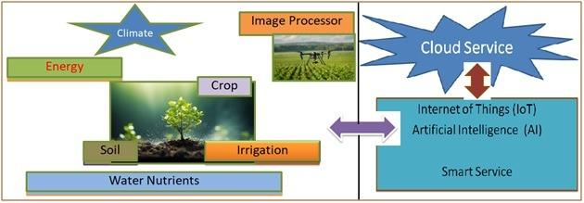The potential of precision farming to advance sustainability is one of its main benefits. Farmers may conserve water resources by optimizing irrigation through the use of real-time data, which guarantees that water is only applied when and where it is needed. In a similar vein, careful use of herbicides and fertilizers lowers the possibility of misuse, which can contaminate water and degrade soil. Precision farming technologies help to protect ecosystems and soil health for future generations by providing focused interventions that lessen the environmental impact of agricultural operations. Additionally, through increasing productivity and decreasing losses brought on by ineffective agricultural methods, these technologies have the potential to improve food security and raise crop yields.

Figure 1: Agricultural System

## **SOLUTIONS - CREATING A SUSTAINABLE FOOD FUTURE BY 2050**

**[Gunn] [COMPLETED]**

The need for food will rise sharply as the world's population exceeds 10 billion people by 2050, placing tremendous strain on our agricultural systems. We can, however, develop a sustainable food future that satisfies this need while reducing adverse environmental effects if we employ the appropriate innovations and tactics. Systemic changes in food production and consumption, resource efficiency, technological innovation, and supportive policies are all necessary to achieve this. We offer a more thorough analysis of the solutions in several important areas below.

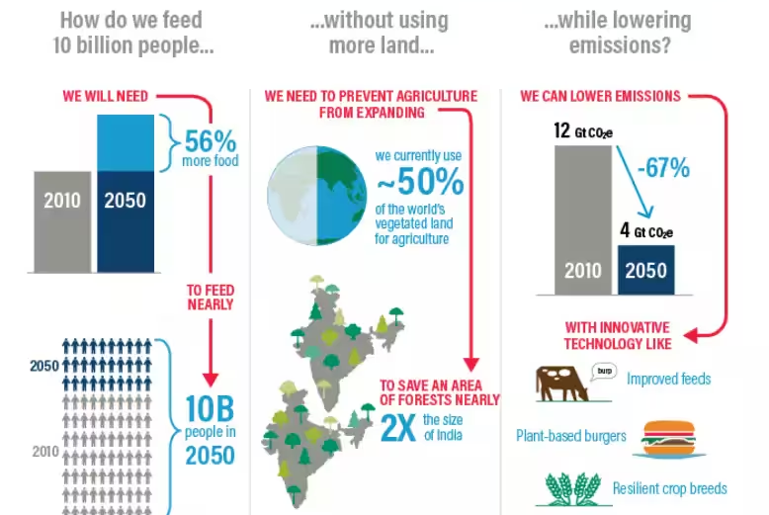

Figure 2: Draw This picture in own and give the picture name

## **Agricultural Innovation**

Application of Smart Sensors and IoT: Farmers may gather real-time data on crop health, temperature, moisture content, soil health, and insect infestations by using sensors and Internet of Things (IoT) devices in agriculture. By reducing waste and increasing resource efficiency, this data assists in making better decisions regarding the timing and method of applying pesticides, fertilizers, and water.

Data-Driven Decision Making: Based on historical and current data, farmers may optimize planting patterns, manage irrigation schedules, and forecast crop yields using big data analytics, machine learning, and artificial intelligence. By adjusting procedures to meet particular demands rather than using a one-size-fits-all strategy, this lowers resource consumption, lowers expenses, and boosts productivity.

## **Genetic Improvement and Biotechnology**

**Genetically Modified Crops**: Crops that have undergone genetic alteration are more resilient to environmental stresses like drought and high temperatures, as well as pests and diseases. Drought-resistant maize and Bt cotton are two examples of crops that are already assisting farmers in increasing yields while lowering the requirement for chemical treatments.

**Gene Editing with CRISPR**: With the use of CRISPR and other gene-editing technologies, crops can be more precisely modified to improve particular qualities like disease resistance, drought tolerance, or nutritional value (e.g., biofortified rice with increased vitamin A levels) without introducing foreign DNA.

## **Vertical Farming and Urban Agriculture**

**Vertical Farming**: Vertical farming optimizes land use by cultivating crops in vertical planes or stacked layers, which eliminates the need for expansive acreage and drastically reduces water consumption. In urban settings with limited land for traditional farming, hydroponics, aeroponics, and aquaponics can be used to minimize soil dependence and water usage.

**Urban Farming Initiatives**: In addition to vertical farming, urban agriculture can include community gardens, rooftop farms, and even indoor farming systems, allowing cities to become more self-sufficient in food production while reducing transportation emissions.

## **Automation and Robotics**

**Robotic Harvesting and Planting**: Automation is transforming labor-intensive tasks like planting, weeding, and harvesting. Autonomous tractors, Drones, and harvesters are increasingly capable of performing these tasks, reducing labor costs, improving efficiency, and reducing human exposure to harmful chemicals and environmental risks.

**Robotic Weeding and Pest Control**:AI-enabled robotics can precisely target pests and weeds without the need of dangerous chemicals. By identifying and eliminating weeds early on, these systems can lessen the demand for pesticides and herbicides.

## **Sustainable Resource Management**

## **Efficient Water Use and Management**

**Smart Irrigation Systems:** Water is only provided directly to plant roots when it is required thanks to technologies like drip irrigation and precision irrigation that are managed by moisture sensors. This avoids over- or under-irrigation, reducing water waste and increasing crop yields.

**Rainwater Harvesting and Recycling**: Reliance on groundwater and other freshwater resources can be greatly decreased by collecting rainfall for agricultural purposes. Water consumption efficiency can also be increased by using water recycling technologies that purify and repurpose water in farms and industrial plants.

## **Soil Health and Fertilization Techniques**

**Organic Farming Practices:** Composting, crop rotation, and agroforestry are examples of organic farming practices that improve soil fertility and microbial activity. These methods also improve soil health over time, lessen pollutants in the environment, and lessen the need for synthetic pesticides and fertilizers.

**Adoption of Precision Farming with Digital Agriculture Technologies**: Over-application of fertilizers can be significantly decreased by using sensors, Drones, and AI-based models to precisely identify fertilizer needs. In addition to saving farmers money, this reduces nitrogen runoff, which can contaminate water supplies and cause lakes and rivers to become eutrophic.

**Regenerative Agriculture:** To improve soil carbon absorption and lessen soil erosion, this includes techniques like cover crops, no-till farming, and combining crop and livestock production.

## **Renewable Energy Integration**

**Solar-Powered Agriculture**: Solar-powered irrigation pumps, greenhouse heating, and solar panels on farm buildings are some ways that solar energy can be incorporated into farming. As a result, farming operations have a smaller carbon footprint and are less reliant on fossil fuels.

**Bio energy from Agricultural Waste**: Straw, corn stalks, and animal dung are examples of agricultural waste that can be transformed into bio energy (such as biogas or bio fuels). This lowers greenhouse gas emissions, waste, and gives farm operations a sustainable energy source.

## **Circular Economy for Agriculture**

**Waste-to-Resource Systems**: Crop residues, food scraps, and manure are examples of agricultural by-products that can be recycled into useful materials.

**Reducing Food Losses and Waste**:It is essential to reduce food waste at the farm and consumer levels. While awareness programs might motivate consumers to minimize food waste at home, innovations in packaging, storage, and logistics can increase shelf life.

## **Food System Transformation**

## **Diet Diversification and Sustainable Consumption**

**Promotion of Plant-Based Diets**: A switch to plant-based diets can drastically cut down on energy, water, and land use because animal husbandry uses a lot of resources. In addition to providing a sustainable substitute for animal products, plant-based protein sources (such as beans, pulses, and nuts) can also enhance public health.

**Sustainable Meat Alternatives**: An alternative to conventional livestock husbandry is offered by lab-grown meats, which are created from animal cells under regulated settings. In the long run, these products might be less resource-intensive and more energy-efficient than traditional meat manufacturing.

## **Reducing Food Waste**

**Improved Storage and Transportation**: Perishable food shelf life can be increased with the use of technologies like refrigeration, improved packaging, and efficient transit logistics. Furthermore, in rural and emerging areas, improved cold storage facilities could stop large losses before food even reaches markets.

**Consumer Education and Awareness**: Household waste can be significantly decreased by educating customers about food waste, proper food storage, and how to use leftovers. Initiatives such as 'ugly produce' marketplaces, which promote the consumption of cosmetically flawed but perfectly good product, can also aid in reducing food waste.

## **Alternative Proteins and Food Innovation**

**Cultivated Meat**: The environmental impact of meat production could be significantly decreased with lab-grown meat, which is made by growing animal cells instead of breeding animals. Businesses are already increasing output, and these technologies may eventually result in meat options that are more accessible, economical, and sustainable.

**Insect Farming**: Compared to traditional livestock, insects—like mealworms and crickets—are high-protein diets with a significantly smaller environmental impact. Encouraging insect farming as a sustainable protein source could reduce resource consumption and offer a substitute food source.

**Food Hubs and Localized Food Systems**: Creating local food hubs that connect farmers directly with consumers can reduce the distance food travels and minimize transportation emissions.

## **Policy and Societal Support**

## **Supportive Government Policies**

**Incentives for Sustainable Practices**: Farmers that embrace sustainable methods like organic farming, water conservation, and the utilization of renewable energy sources can receive financial incentives, grants, and subsidies from their governments.

**Regulations on Food Waste**: In addition to requiring improved food labeling techniques to notify consumers about portion sizes and expiration dates, governments can enact laws requiring companies to donate excess food or repurpose trash.

## **Investment in Research and Development (R&D)**

**Public-Private Partnerships**: Innovation in sustainable agriculture can be fueled by cooperation between the public and commercial sectors. Long-term food security will depend on increased funding for agricultural R&D aimed at developing alternative proteins, water-efficient technologies, and climate-resilient crops.

**Global Collaboration on Sustainability**: International research partnerships and knowledge transfer can be advantageous for developing nations, who are frequently the most impacted by food poverty. In areas that most need it, this international information exchange could boost agricultural productivity.

## **Education and Farmer Support**

**Training Programs and Knowledge Transfer**: The adoption of these solutions will rise if farmers have access to training programs on new technologies, best practices, and sustainable agricultural methods.

**Support for Smallholder Farmers**: When it comes to implementing new technologies, smallholder farmers frequently confront the biggest obstacles, particularly in developing nations. Their success in a sustainable food system depends on giving them access to funding, technical know-how, and market opportunities.

## **Promoting Global Cooperation**

**International Agricultural Research Networks**: Strengthening international partnerships in agricultural research, technology development, and resource management can facilitate the transfer of knowledge and resources to regions facing food security challenges.

**Climate Change Adaptation Funds**: The World Bank and the United Nations are two examples of international organizations that can set up grants to help nations reduce agricultural emissions and adopt climate-resilient farming practices.

## **Public Awareness and Consumer Engagement**

**Sustainable Consumption Campaigns:** Governments and NGOs can launch public campaigns to raise awareness about the environmental impacts of food choices and encourage consumers to opt for more sustainable products.

## **AGRICULTURE TECHNOLOGIES**

**[Gunn] [COMPLETED]**

Over the ages, agriculture has experienced tremendous change, developing from conventional farming methods to a highly sophisticated, technologically driven sector. The importance of technology in agriculture has grown as the world's population continues to rise and environmental problems like resource depletion and climate change worsen. By increasing sustainability, guaranteeing food security, and increasing productivity, agricultural technologies have the potential to address these issues. This section examines the several agricultural technologies that are transforming contemporary farming and how they can influence food production in the future.

## **Precision Agriculture: A Data-Driven Approach**

The employment of cutting-edge technologies to precisely monitor and control agricultural practices is known as precision agriculture. In order to gather, examine, and use real-time data to enhance farming methods, it incorporates technologies like GPS, sensors, Drones, and data analytics. Precision agriculture increases productivity and decreases resource waste by empowering farmers to make better decisions, which leads to increased yields and more environmentally friendly methods.

* **GPS and Remote Sensing**: Accurate field mapping and exact resource application, including water, fertilizer, and pesticides, are made possible by GPS technology.
* **Variable Rate Technology (VRT)**: Based on the unique requirements of various regions, VRT allows farmers to apply inputs (such fertilizers and insecticides) across their fields at varied rates. This optimizes resource utilization, minimizes environmental effect, and lessens input misuse.
* **Automated Machinery**: With GPS and automation systems, tractors, harvesters, and other pieces of equipment may operate independently, saving money on labor and boosting productivity. These devices can be configured to operate continuously, increasing output while lowering the risk of human error and exposure to dangerous situations.

## **Robotics and Automation: Enhancing Efficiency and Reducing Labor Dependency**

Robotics and automation have revolutionized various industries, and agriculture is no exception. The development of robots and automated systems is transforming labor-intensive tasks such as planting, weeding, harvesting, and packaging. These technologies not only increase efficiency but also help address labor shortages, reduce human exposure to chemicals, and improve precision in tasks such as seed planting and weed removal.

* **Robotic Harvesting**: Ripe crops can be identified and picked more quickly by automated harvesters that are outfitted with AI and machine learning algorithms than by human workers. This guarantees that fruit is gathered at the ideal time for quality and flavor, cuts down on crop loss, and shortens the harvesting period.
* **Weeding and Pest Control:** By using artificial intelligence (AI) to distinguish between weeds and crops, weeding robots can eliminate undesired plants without endangering crops. Similar to this, autonomous pest control systems may identify and target certain pests, decreasing environmental impact and the requirement for widespread pesticide treatments.

## **Artificial Intelligence (AI) and Machine Learning: Optimizing Farm Management**

Artificial intelligence and machine learning technologies are increasingly being used in agriculture to optimize decision-making, predict crop yields, and improve resource management. These technologies can analyze vast amounts of data from sensors, Drones, and satellites to identify patterns and provide actionable insights to farmers.

* **Predictive Analytics for Crop Management**: In order to forecast crop yields, foresee pest and disease outbreaks, and suggest the best periods for planting and harvesting, AI-powered systems can evaluate both historical and current data. These systems can also recommend ways to reduce the risks associated with illnesses, pests, and weather variations.
* **Automated Decision-Making**:Using information from weather forecasts and environmental sensors, artificial intelligence (AI) can be incorporated into farm management systems to automate critical decisions like fertilizer application rates and irrigation schedules. By ensuring that resources are deployed precisely when needed, waste is decreased and overall farm efficiency is increased.

## **PRECISION FARMING WITH DIGITAL AGRICULTURE – DRONE Technologies**

**[Harsh] [COMPLETED]**

Modern farmers have turned to new technologies, such as precision agriculture UAVs (unmanned aerial vehicles) or Drones, to maximize every inch of cropland.

What is Agriculture UAV in Precision Farming? UAV refers to ‘unmanned aerial vehicles’, also called ‘Drones’. These aerial technologies for producing crops are based on utilizing these agriculture UAVs. Therefore, growers can easily observe the field without manual support. Initially, farmers used crop dusters for traditional watering and sowing.

## **Why Adopt Precision Agriculture UAV?**

In precision agriculture, Drones help farmers tackle various challenges and gain multiple advantages. The world as we know it today is rapid and all the changes happen in almost a blink of an eye. We know adaptation is crucial, but change is the only constant. As the population grows and weather conditions change globally, farmers must utilize new-generation technologies to address emerging challenges.

## **How does Precision Farming Drones Work?**

Generally, Drone construction includes sensory motors, GPS, cameras, and controllers as well as a piece of equipment for automated flights. The [technology used for precision agriculture UAV Drones](https://iotechworld.com/application-of-drones-in-indian-agriculture/) are made in a way that enables them to capture more accurate information than airplanes and satellites can collect.

## **Types of Drones used in Agriculture**

1. Fixed-wing Drones: Fixed-wing use the lift and drag to maintain altitude in the same way as airplanes do. They are fairly simple to operate. It has a non-movable wing and a propeller that allows it to go ahead. Because of its design, it must always be moving relative to the air surrounding it in order to stay aloft.
2. Fixed-wing hybrid VTOL Drones: A new category of hybrids that can take off and land vertically combines the benefits of fixed-wing Drones with hovering ability. Fixed-wing hybrid VTOL (Vertical Take-off and Landing) Drones combine UAV (Unmanned Aerial Vehicle) qualities with the ability to fly in a single location while keeping hybrid traits.
3. Multi Drones: Multi-rotor Drones are the most commonly used for mapping and modeling. These are made up of a fuselage and four motors that power the proper propellers. Multi-rotor are a fantastic choice for aerial photography due to their compact size and outstanding control. They can simply hover and take off vertically, giving them even more mobility and handling heavier weights.
4. Single-rotor helicopter: Single rotor helicopter Drones have more advantages than other types. It has a gas-controlled mechanism to boost endurance. Aerodynamic standards stress that larger rotor blades result in less spinning and greater system reliability. As a result, single rotor helicopters are more practical than other types
5. Tethered Drone: A tethered vehicle is a typical Drone that is tethered to a wire in order to eliminate the need for a remote controller. Drone movement is thus constrained by the tether. Furthermore, tethered Drones come in a wide range of configurations.

## **Benefits of Drones in Precision Farming**

### Crop Monitoring and Health Assessment

* + Multi-spectral and RGB Imaging: Drones equipped with multispectral cameras can capture images in different wavelengths, allowing for a detailed analysis of crop health. This helps in identifying areas affected by diseases, pests, or nutrient deficiencies early.
  + NDVI Analysis: The Normalized Difference Vegetation Index (NDVI) generated from Drone data can assess plant health based on chlorophyll levels, indicating stress or poor health before visible symptoms arise.

### Soil and Field Analysis

* + Soil Health Mapping: Drones can collect data on soil properties such as moisture content, organic matter, and compaction.
  + Seed Planting Precision: Drones can map fields to identify optimal planting spots, which can increase seed germination rates and yield while reducing waste.

### Irrigation and Water Management

* + Real-Time Water Stress Monitoring: Drone data can show variations in soil moisture and plant water stress, helping farmers determine when and where to water.
  + Irrigation System Optimization: By integrating Drone data with IoT sensors and irrigation systems, farmers can automate watering schedules, optimizing water use and reducing waste

### Precision Spraying

* + Targeted Application of Fertilizers and Pesticides: Drones equipped with spray systems can apply chemicals precisely where they’re needed, reducing the environmental impact and cost of chemicals.
  + Reduced Exposure for Workers: Using Drones for spraying in large fields minimizes direct human exposure to potentially harmful chemicals.

### Yield Prediction and Harvesting Optimization

* + Growth Stage Monitoring: Drones allow farmers to monitor crop growth and forecast yields by assessing plant biomass and health throughout the growing season.
  + Harvest Timing: Drone data can help determine the optimal time to harvest by analyzing plant maturity and readiness.

1. Livestock Management
   * Herd Monitoring: Drones can monitor livestock across large pastures, checking animal locations and health while minimizing human effort.
   * Pasture Analysis: Drones can assess pasture quality and identify overgrazed or underutilized areas, helping manage grazing rotation schedules.

## **COMPONENTS OF PROPOSED TECHNOLOGIES & DIFFERENT FUNCTIONALITY**

**[Anushka] [COMPLETED]**

The digital component of agriculture can be divided into three features

* Data and data collection systems include yield and soil monitoring systems, various sensors, images from Drones, aircraft or satellites, etc.
* Decision Support (DS) tools maps or other visualization of geo-referenced electronic data, management recommendations, smartphone app data
* Data-driven equipment and data adjustment such as guidance system, automated section control, VRT applicator etc

Distributed ledger technology such as BlockChain can be used to ensure data quality and traceability. Digitalization can only be explored through reviewing underlying technology and associated data usage.

Soil physical-chemical analysis, yield change over small areas, physical yield maps, custom application of seeds or fertilizer using VRT, reduction of field overlap through data-driven Guidance systems, and Image analysis that are sensed remotely by Drones, aircraft etc are a few technology components for digitalization. Controlled traffic farming is a practice that limits the exposure so that equipment returns the same returns for as many fields. Automated section control shuts the equipment portion which is not required. Finally, telematics transfers the data between the equipment and connected devices or the cloud via the cellular system or Local Area Network (LAN). Also nowadays highly specialized and mobile agricultural robots are used for farm digitalization. Also use of the Global Positioning System (GPS) make it possible to create maps, enable automated control mounting with VRT and facilitate modern guidance systems. This satellite navigation system are fundamental technology component that supports farming management. The quality of satellite signal with geography is constrained for crop growing and responsible for net return to GNSS applications.

Other technology concepts are widely used in farming system

* Emerging Digital Technology
* Artificial Intelligence and Machine Learning

These computer innovations enable greater productivity across agricultural sectors. Large-scale implementation is required for better results with these technologies with proper algorithm change for repeatable tasks that involve certain kinds of decision-making.

It is essential to integrate component technology into the digital system for greater use where each component technology empowers the farm operator to better implement, harvest and analyze the experiment for that component to be used in a holistic system.

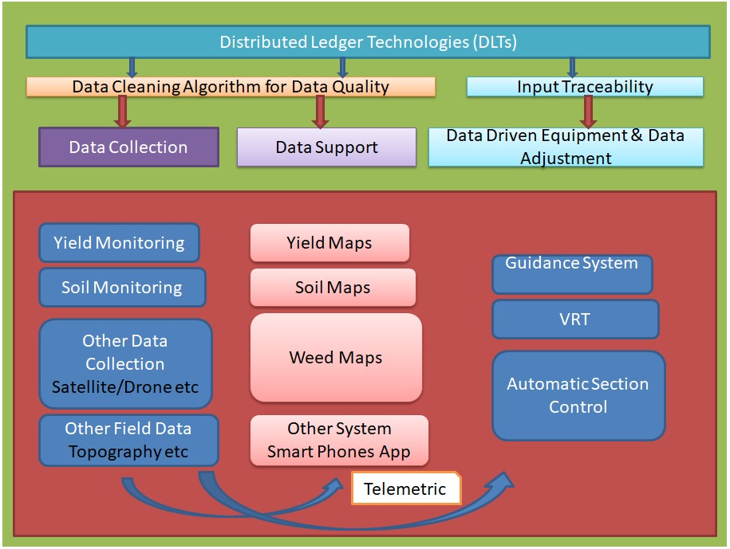

Arrows indicate the flow of hardware, software or information as input to decision support technologies and/or data-driven equipment or input adjustment. The system is capable of being automated

Fig 3 - Key component technologies of Digital Agriculture (DA)

## **COMMUNICATION ARCHITECTURE OF PROPOSED TECHNOLOGIES & DIFFERENT FUNCTIONALITY**

**[Harsh][COMPLETED]**

**Architecture for Precision Farming Solution**

This section describes the proposed architecture for a precision farming solution, designed to optimize resource utilization and improve crop yields through data-driven decision-making. The architecture is structured into four distinct layers: the Sensing Layer, the Network Layer, the Decision Layer, and the Application Layer.

**Sensing Layer**

The foundation of our precision farming solution lies in the **Sensing Layer**. This layer is responsible for collecting real-time data from the field using a variety of sensors strategically deployed across the farm. These sensors include:

* **Soil Sensors:** Measure soil moisture, temperature, nutrient levels, and pH, providing insights into soil health and fertility.
* **Water Sensors:** Monitor water levels in irrigation systems, rainfall, and soil water content to optimize irrigation schedules.
* **Wind Sensors:** Track wind speed and direction, crucial for predicting evapotranspiration rates and potential wind damage.
* **Light Sensors:** Measure light intensity and duration, essential factors for photosynthesis and crop growth.
* **Proximity Sensors:** Detect the presence of objects or changes in distance, potentially used for monitoring plant growth or detecting pest infestations.

The data collected by these sensors forms the basis for informed decision-making in the subsequent layers.

**Network Layer**

The **Network Layer** provides the communication infrastructure for transmitting data from the Sensing Layer to the Decision Layer. This layer utilizes a combination of technologies to ensure reliable and efficient data transfer:

* **IoT Nodes:** Serve as the interface between the sensors and the network, collecting sensor data and transmitting it wirelessly.
* **Base Stations:** Act as aggregation points for data from multiple IoT nodes, providing wider network coverage.
* **Gateway:** Connects the local network to the cloud, enabling data transmission to the Decision Layer.
* **Cloud:** Provides a scalable and reliable platform for data storage, processing, and analysis.

**Decision Layer**

The **Decision Layer** is the core of the system, responsible for processing the data received from the Network Layer and generating actionable insights. Key components of this layer include:

* **Workstations:** Used by agronomists and data scientists to analyse data, develop predictive models, and fine-tune decision-making algorithms.
* **Application Server:** Hosts the software applications responsible for data processing, analysis, and decision support.
* **Knowledge Base:** Stores historical data, crop models, best practices, and other relevant information used to inform decision-making.

This layer leverages data analytics, machine learning, and domain expertise to generate recommendations for optimizing irrigation, fertilization, pest control, and other farming practices.

**Application Layer**

The **Application Layer** provides a user interface for stakeholders to access information, monitor farm conditions, and implement decisions. This layer caters to different user groups:

* **Academicians:** Use the data and insights for research purposes, contributing to the advancement of precision farming techniques.
* **Experts:** Provide their knowledge and expertise to refine the decision-making algorithms and improve the overall system performance.
* **Farmers:** Utilize the recommendations generated by the system to make informed decisions about their farming practices, ultimately leading to improved crop yields, reduced resource consumption, and increased profitability.

This layered architecture enables a holistic approach to precision farming, integrating data collection, communication, processing, and decision-making to optimize agricultural practices.

**Enhanced Architecture: Cloud Database Integration**

Integrating a cloud database enhances our precision farming solution by providing:

* **Scalability:** Adapts to growing data volumes.
* **Centralized Access:** Facilitates data sharing and remote management.
* **Robust Security:** Protects sensitive farm data.
* **Simplified Management:** Automates backups and maintenance.
* **Advanced Analytics:** Enables predictive modelling for optimized farming.

The cloud database integrates as follows:

* **Network Layer:** Gateway transmits sensor data (JSON/XML) securely.
* **Decision Layer:** Application server queries the database (SQL) for analysis.
* **Data Pipeline:** Raw data is ingested, processed, and stored.

This integration yields improved decision-making, crop yields, resource efficiency, and farmer profitability.

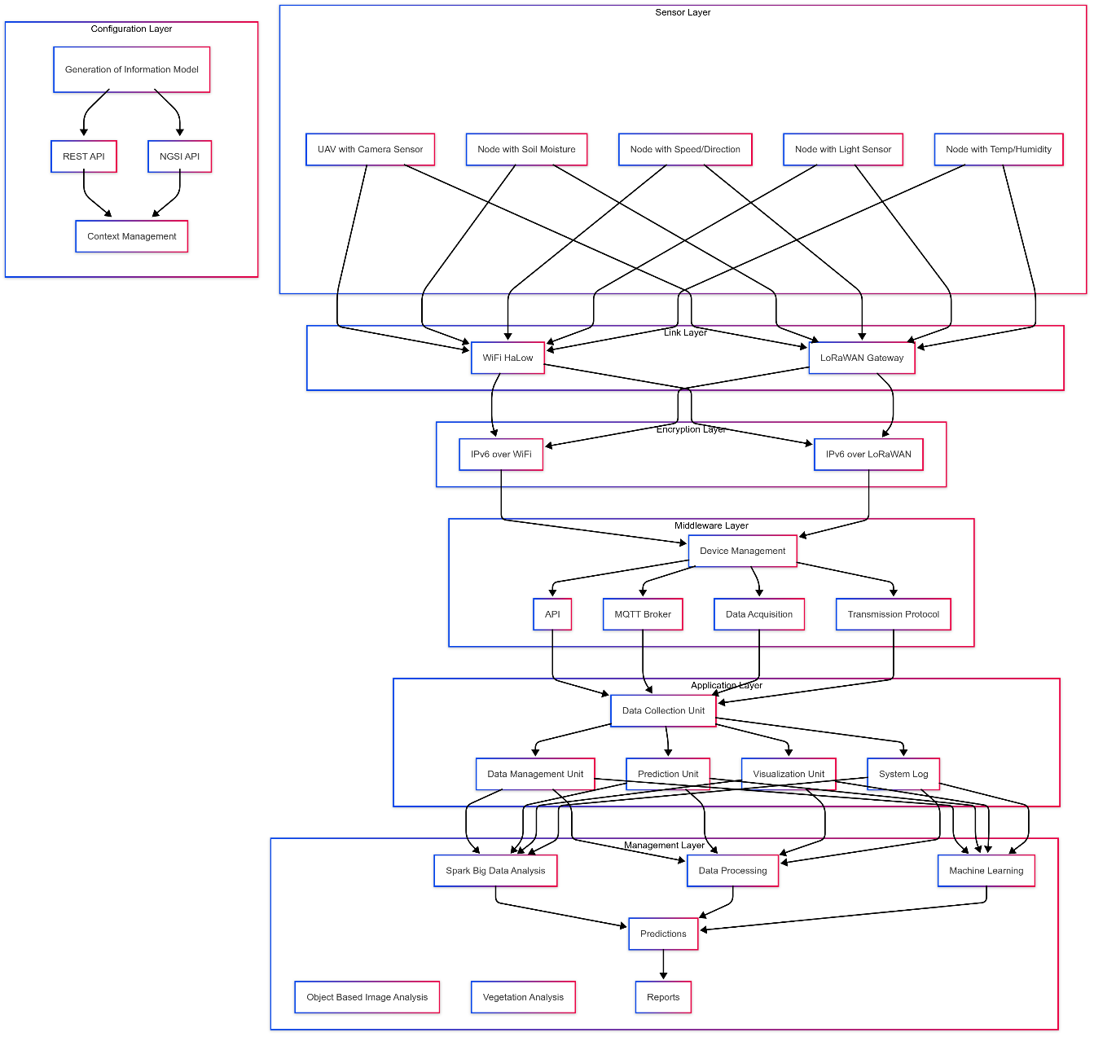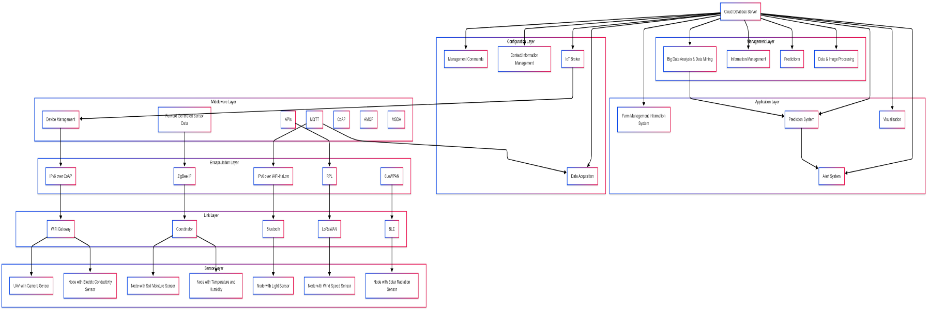

## **PROPOSED SMART-AGRICULTURE-AS-A-SERVICE – SMART FARMING TOOL**

## **A Smart Crop Management using Smart IoT and AI-based Solutions**

## **[Gunn]**

## 

## **Proposed Distributed Computing Architecture on IoT**

## **[Anushka]**

Combine the below Four picture in a single picture and create a write up

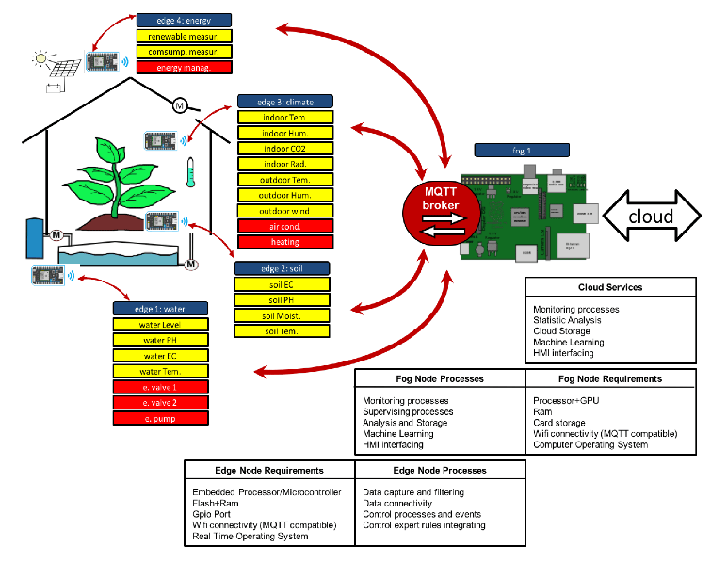

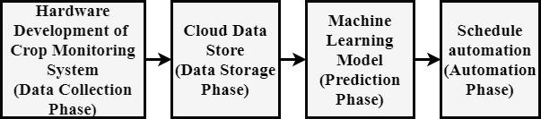

Block Diagram of Proposed System

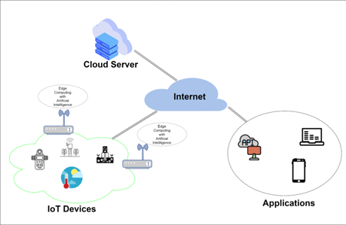

Communication and processes

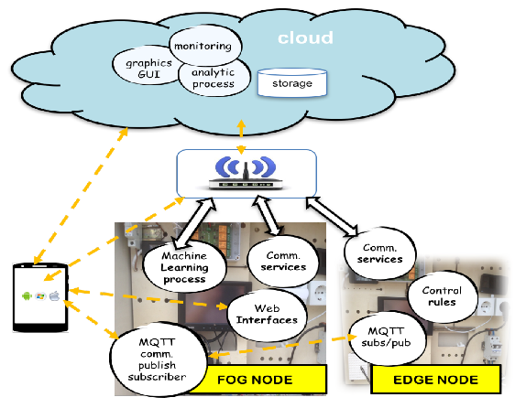

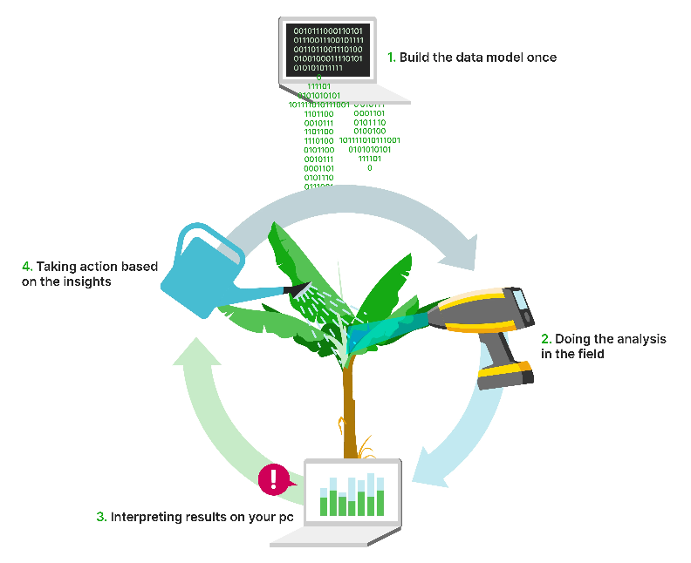

## **PROPOSED SOFTWARE ARCHITECTURE**

## **Smart Return Agriculture Solution Architecture**

## **[Gunn]**

An android application or web application can be created to provide a platform to monitor the real-time data collected from the sensors which will assist the farmers to take necessary action to improve the crop productivity. The farmer has to register the application by providing basic personal and field information. The farmer can view all the information regarding the farm.

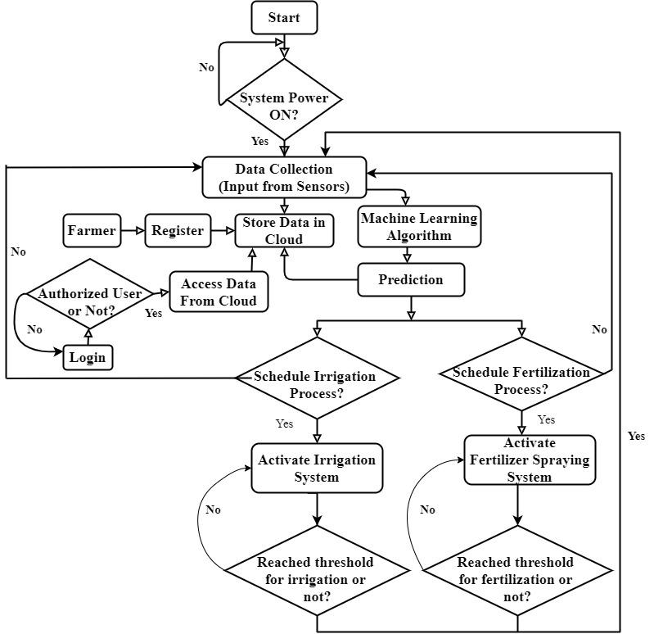

**Fig 6: Farm Management Software**

## **Agri App Proposed System**

## **[Harsh][COMPLETED]**

Our final proposal for precision farming rests on our prototype for an Agribusiness Soil Monitoring smart application called FarmOS. Our mobile application for agribusiness and soil monitoring requires integrating features that cater to diverse user roles (farmers, middlemen, organizations, specialists) while addressing core services like business connectivity, yield prediction, financial/legislative updates, specialist recommendations, and climate forecasting.

Key Features of FarmOS application :

**1. Business Connectivity**

* **Marketplace Integration**: Enable farmers to connect with middlemen/organizations for input procurement (seeds, fertilizers) and output sales. Include price-comparison tools and secure in-app payments.
* **Supply Chain Transparency**: Provide real-time tracking of goods, logistics coordination, and contract-management tools for organizations.

**2. Yield Prediction & Soil Monitoring**

* **AI-Driven Analytics**: Integrate soil health data (pH, nutrient levels, organic matter) via IoT sensors or manual input, combined with satellite imagery and historical yield data for predictive modeling using Image Recognition Systems and Deep Learning CNN and Neural Networks.

**3. Financial & Legislative Updates**

* **Customized News Feed**: Curate government schemes, subsidies, and policy changes with location-based filters. Use push notifications for urgent updates.
* **Profitability Dashboards**: Display cost-of-production, grain sales trends, and insurance option.
* **Access Current Price Rates:** Provide real-time market prices for crops, fertilizers, and other essential agricultural inputs. Integrate data from government portals, local towns, and commodity exchange platforms to ensure accurate and up-to-date information.

**4. Specialist Recommendations**

* **Video Consultations**: Allow farmers to connect with agronomists via in-app video calls.
* **AI Chatbots**: Provide instant advice on pest control, crop rotation, and soil management.

**5. Climate & Weather Forecasting**

* **Hyper-local Weather Alerts**: Integrate real-time forecasts, drought/pest risk warnings, and irrigation scheduling tools.
* **Historical Climate Data**: Enable yield comparisons across seasons.

**6. Soil Monitoring and Weed / Anomaly Detection:**

* ****Image-Based Soil Analysis:** Allow farmers to capture soil images for AI-driven analysis of texture, color, and fertility.**
* ****Weed & Pest Detection:** Use deep learning to identify weeds, pests, or crop diseases from uploaded images and provide treatment suggestion.**
* ****Anomaly Alerts:** Detect abnormal plant growth or nutrient deficiencies through image recognition and recommend corrective actions.**

| ****User Role**** | ****Key Features**** |
| --- | --- |
| **Farmers** | Soil health reports, weather alerts, marketplace access, subsidy notifications |
| **Middlemen** | Inventory tracking, price trends, buyer-seller matchmaking |
| **Organizations** | Supply chain analytics, compliance tools, bulk procurement portals |
| **Specialists** | Case management, knowledge-sharing hubs, remote soil diagnostics |

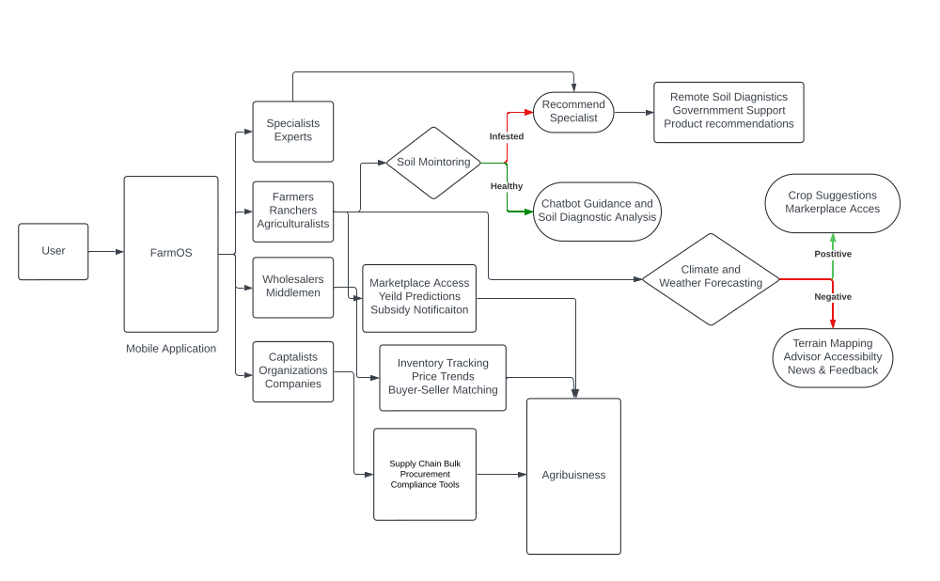

| **FarmOS**  is an Agri App. It is a web-based cultivating commercial centre, bringing agriculturists, cultivating input/yield, taxpayer supported organization on an online stage. It likewise gives visit choice to agriculturists. Ranchers can without much of a stretch visit with a specialist of farming utilizing this application. This versatile application gives broadened recordings of agribusiness work. |
| --- |
| This android application gives data about the most recent agribusiness exhortation, most recent market costs, and different cultivating tips. It likewise gives climate figure data. The ranchers can without much of a stretch take help of agribusiness specialists utilizing this application. Pre-Fault Detection. |
| This android application gives mastery by reaching the specialists through the talk bot and furthermore enables the ranchers to transfer any related pictures to the issue. This cell phone application likewise gives different recordings identified with agribusiness practice, new advancements, effective ranchers, provincial improvement, farming news, new govt. plans identified with horticulture. |
| It gives rich farming substance and data at each phase of the yield life cycle. An agriculturist can browse 450 harvest assortments, 1300 markets, 3500 climate areas. It likewise gives advertise cost and climate figure dependent on a client area. |
| It gives data pretty much all Govt. plans to Farmers. It drives the data hole between the rustic individuals and Govt. It additionally gives the plans of the distinctive relative states Government. This versatile application likewise spares the time and travel cost of Farmer to achieve the state Govt. office is spared. |
| Proposed framework is additionally, an android application which underpins the agriculturists on an online stage. It does not require any talk highlight to give ability to the agriculturists yet recommend the best products to the ranchers to be sowed in a farm as per the present area properties and the interest and supply in the market |
| This android application gives latest market costs to the agriculturist. It not just gives the anticipated climate estimate of the favoured region yet in addition think about the climate of the favoured territory with the past climatic states of that specific zone. All the yield subtleties are given through the informational collections which are as of now accessible on the web. It gives skill to the agriculturist with no talk bot. |
| No visit both is utilized in this versatile application. Since the horticulture procedures are now known to rancher the application gives the data to the agriculturist which he probably won't think about it while cultivating because of absence of information. This application does not give any news through recordings to the ranchers. |
| This android application gives insights regarding the yield is prepared to be gathered or not. A rancher can look over a ton of yield assortments, climate figure and additionally past climatic conditions. It likewise gives current market costs and climate gauge dependent on a ranch area. |
| This android application gives the economic situations like interest and supply of the market, ebb and flow costs for the create, climatic conditions, and more zone |

## **Software Prototype**

## **[Harsh, Gunn and Anushka]**

## **Advantages**

## **[Anushka]**

## ` The aforementioned applications aim at the efficient field and crop management to

## Increase production efficiency

## Improve product quality

## Provide more efficient use of chemicals in cultivation

## Manage pesticide amounts

## Reduce energy consumption

## Protect the soil and improve soil health

## Control water consumption and underground water amounts

## Control Waste Management

## Reduce Production Cost

* Climate Conditions
* Pre-fault detection. Detection of faulty terrain or ungrazed land where weed could potentially disrupt the crop management.

## **CONCLUSION**

In Today’s world mobile applications play a vital role in all aspects of life. Major progress is seen in financial applications, Educational applications, Entertainment, Social media applications and IT apps. But Agricultural applications haven’t made enough progress given its economic importance in a country like India. Smartphones with more computing power is more affordable now. Even Internet services are cheaper. India is diverse country with a number of native languages but most of the agricultural applications in today’s market are in English which farmers in India may find difficult to understand. There is a need for agricultural applications which can focus on peculiarities of specific geographical areas for providing more accurate and efficient information to the farmers. Also, we need applications that can help monitor farms dynamically in real time rather than static or outdated information. This can be done by adopting Precision Agriculture. If a single application can provide the necessary information on seed, crop estimation, pesticides, fertilizer, harvest time, estimation of yield that will be produced including weather conditions and can also connect the farmer which the market so that he can understand the demand and supply for the crops he grows it will immensely help the farmers.

Precision farming tools are transforming agriculture by providing detailed insights and enabling precise control over farming practices. From GPS systems and Drones to soil sensors and autonomous machinery, these tools help farmers increase efficiency, reduce costs, and boost yields. As technology continues to advance, the adoption of precision farming tools for agriculture will only grow, leading to more sustainable and productive farming practices. Embracing these innovations not only ensures better resource management but also contributes to the overall health of the environment.

## **References**

1. RRR